Research Question and Goals of Analysis
Research Question:
Can we accurately automate the process of determining positive or negative opinions from a collection of reviews using a neural network?
Objectives of the Analysis
Determine whether we can predict the quality of sentiments using a neural network with a high level of accuracy.
What determines a high level of accuracy?
High level of accuracy would be greater than 80% in the training set, and 70% accuracy in validation and the test set.
Why are these objectives important and how do they prove an effective model?
If the model achieves the two accuracy scores above the model will be able to classify the sentiment of a review or sentences that it has already seen and those that are similar to the sentiments the model has already seen with a 80% accuracy, and the model will be able to classify sentiments of unseen reviews with a 70% accuracy.
Type of Network
I will be building a Recurrent Neural Network as they can use previous inputs to aid them to make predictions. As language has an abundance of words and several have similar meanings, the model will be able to pick up on patterns of different combinations of words to determine the sentiment because it will optimize itself based on an accuracy score of its predictions. Specifically I will be using a Long short-term memory (LSTM) network as my RNN because after heavy testing I found it to be the highest performing model type and it had the bonus of being comprised of less hidden layers than other models. I do not know exactly what makes it perform better, but I think it has to do with the regularization features with the dropout parameter and the model’s ability to detect unimportant information.
Data Preparation
Exploring the Review Dataset
Prior to Cleaning
The following unusual or non-English characters appeared in the dataset: –, ¥,ª, …, ã, ©, —, â

Review Description
Average Review Length: 12
Median Review Length: 10
Shortest Review Length: 1
Longest Review Length: 71
Words Description
Size of vocabulary: 6836
Average Word Length: 5
Median Word Length: 4
Shortest Word Length: 1

After Cleaning Data
Sequence Description
Average Sequence Length 6
Median Sequence Length 5
Max Sequence Length 42
Token Description
Average Word Length of the Corpus 6
Median Word Length of the Corpus 5
Size of Vocabulary 4623
Average Word Length of Vocabulary 7
Median Word Length of Vocabulary 6
Largest word length 17
* Note at this point the reviews have been tokenized and stop words have been removed.
The proposed word embedding length will be 4623 because that is the size of the vocabulary, we will pass into the neural network embedding layer. The maximum sequence length is 42, the length of the longest review after cleaning.
Cleaning Data
Tokenization
The goal of tokenization is to prepare the sequences of words into a format that is machine readable. For our model we need to transform our reviews into an array of each word, then normalize the words to minimize the amount of words that have similar roots and remove words that occur frequently but add no value to the sentence. Then we encode our words into numbers and use padding to standardize sequence lengths.
My normalization method will be noun lemmatization using the WordNetLemmatizer from the nltk library. I will be using the word_tokenize function from nltk to tokenize my strings.
Tokenizing
From nltk import word_tokenize
From nltk import WordNetLemmatizer
word_tokens = [word_tokenize(review) for review in clean.Sentiment]
Removing Stop Words and Punctuation
#Checking Punctuation Mark Typos in Tokens
def check_tokens(list_of_list):
#List that will replace the list_of_list
replace = []
for l in list_of_list:
replace.append(check_words(l))
#Returning the list of substituted strings
# Stopwords have been removed in two phases now
return replace

#Finding words and seperating them at punctuation marks
def check_words(list_strings):
new_list = []
#Iterating through the list to parse through string characters
for s in list_strings:
#Placeholder to store the string makeup leading up to a punctuation mark
# or the end of the string
hold_s = ''
for char in s:
if (char not in string.punctuation) and (char.isascii()):
hold_s = hold_s + char
# Preventing a "" from being in the string list
elif hold_s != "":
#Preventing stop words and punctuation marks from being added as tokens
if hold_s not in STOPWORDS and (char not in string.punctuation):
new_list.append(hold_s)

hold_s = ''
#Preventing blank strings and stopwords from being added to the list
if (hold_s != '') and (hold_s not in STOPWORDS):
new_list.append(hold_s)

return new_list

clean_tokens = check_tokens(word_tokens)

Lemmatization
#Lemmatization process
lemmatizer = WordNetLemmatizer()
#placeholder to add new sets of sequences to
keep_tokens = []
#Capturing all words that are in the lemmatized and filtered corpus vocabulary
words = []
#Getting descriptive data on words and sequences
word_lengths = []
sequence_lengths = []

#Looping through tokens
for tokens in clean_tokens:
#Placeholder for lemmatized tokens in the sequence
new_tokens = []
sequence_lengths.append(len(tokens))
#Lemmatizing the tokens and collecting information about the words
for token in tokens:
new = lemmatizer.lemmatize(token, pos = 'n')
new_tokens.append(new)
words.append(new)
word_lengths.append(len(new))
keep_tokens.append(new_tokens)
Padding
I used 0s to pad and ensured that the word_index transformation would use 0 as the pad. I used a left pad to standardize the length of sequences to 42, so the pad will be applied before the text sequence.
Example of a padded tokenized sequence:
[0, 0, 0, 0, 0, 0, 0, 0, 0, 0, 0, 0, 0, 0, 0, 0, 0, 0, 0, 0, 0, 0, 0, 0, 0, 0, 0, 0, 0, 0, 0, 0, 0, 0, 0, 0, 'way', 'plug', 'u', 'unless', 'go', 'converter']
Types of Sentiment and Activation Function for Output Layer
There are only two categories of sentiment in this dataset 1 being positive and 0 being negative. The activation function of the output layer will be softmax with two output nodes, softmax will force the two output nodes to sum to 1, so we can consider the output to be probabilities of both the positive and negative class.
Steps to Prepare Data
- Download and import text files
  - Import them 1 file at a time, append each line of the file to a list of lines from all files
- Separate sentiments from scores
- Tokenize the sentiments
- Remove stop words and punctuation marks
- Lemmatize the words
- Pad the sequences (I prefer left pad)
- Record the vocabulary size and the longest length of a sequence
- Create a word index and encode the sequence’s tokens with word index values
- Create an X and Y variable
  - X will be an array comprised of the encoded sequences
    - Use list comprehension to transform sequences from pandas series into arrays and transform the structure of the series of sequences into an array. Code is below.
    - X = np.array([np.array(val).T for val in X])
  - Y will be an array comprised of the known sentiment scores
- Use the to_categorical function to ensure that the model reads the data type correctly.
- Separate the data into a training set and test set
  - Stratify by y to get the same proportion of 0’s and 1’s in both datasets.
  - 70/30 split with a 30 split in the model fit validation set. This uses the industry average train/test split of 70/30 and uses the model fit method parameters to validate the training set using 30% of the training data, so we don’t have to worry about making a validation set or manually testing the validation set. The model does it for us.
Network Architecture
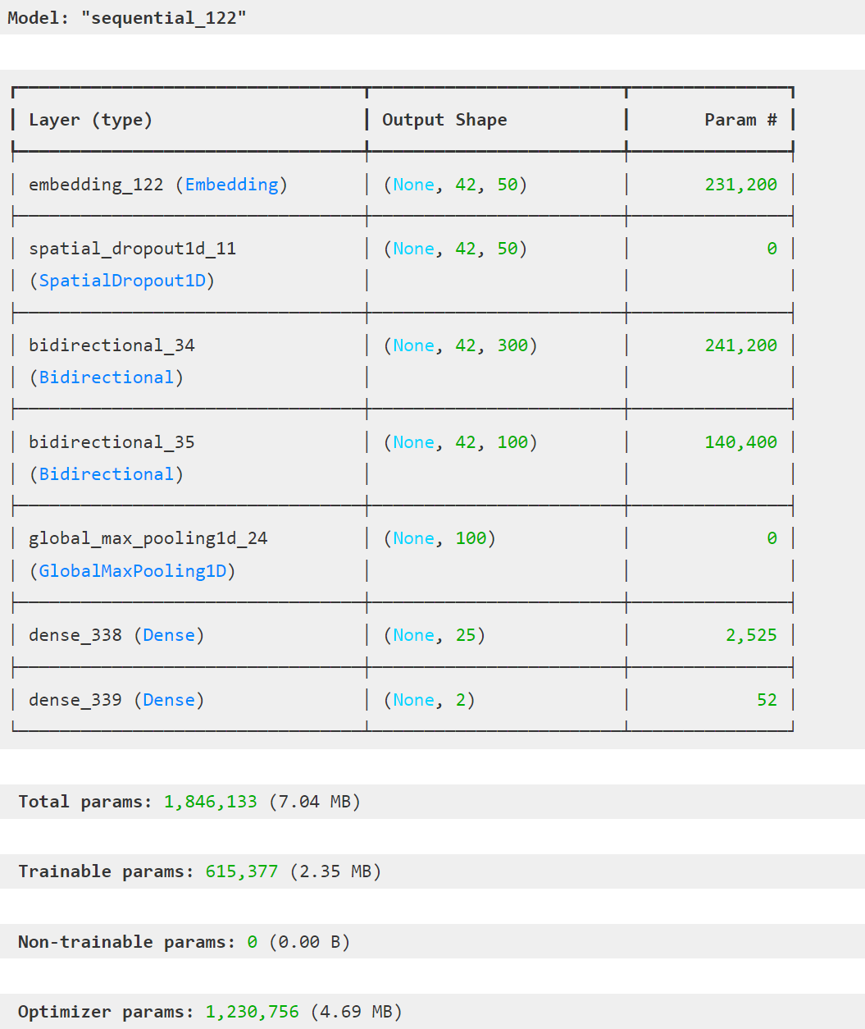
Model Layers
We have 7 explicit layers, 1 Embedding layer, 1 Spatial Dropout layer, 2 bidirectional LSTM (sigmoid activation function) layers which have another hidden LSTM layer within them for training the forward and reverse of the sequences, 1 Max pooling 1d layer and 2 Dense layers (relu and softmax activation functions).
Embedding (50 nodes)
This layer allows the network to learn the word embedding pattern I created over the epochs it trains through. This allows the model to interpret the sequences by word index.
Spatial Dropout 1D (.3 dropout rate)
Reduces the effects of overfitting by randomly selecting a feature output from the word embedding layer and imputing .3 of the selected feature to 0s. For example we have an embedding layer that outputs 50 nodes, one of those nodes will be selected say the 23rd node and for 30% of the batch the model will set 0s for the 23rd node’s outputs. I believe each epoch and batch has a random node selected so a different node may or may not be selected to have a dropout applied throughout the training process.
Bidirectional LSTM
Two layers 1st has 150 output nodes, 2nd layer has 50 output nodes, both have .2 recurrent dropout and a .2 dropout rate. Recurrent dropout of .2 drops .2 of the nodes after updates to the LSTM have been computed.
This layer allows the model to learn context of sequences in a forward direction and then also backwards. This layer allows the model to not only understand how past words relate to one another, but also different interpretations of the sequences based on the words that follow. This can be easier to understand if you think about how people learn how to read when they encounter a new word, they can use context clues to comprehend a sentence based on known words around an unknown word. We are basically giving the network the power to understand sequences front to back so it can learn and compute how word ordering plays a part in interpreting sentiment. The LSTM model allows the network to learn optimal connections for prediction accuracy and forget other connections that hinder prediction accuracy. Dropout is added to reduce overfitting. These layers both use a sigmoid activation function because after testing over 100 models it worked the best in prediction accuracy.
Global Max Pooling
Condenses the output of the last Bidirectional LTSM layer to the largest value returned from the 50 nodes, this was chosen purely out of testing. I trained the model using GlobalAveragePooling and GlobalMaxPooling, the max technique required significantly less epochs to train and ended up with a similar validation accuracy score as the average technique. This layer helps reduce overfitting as well and provides an acceptable format to input into the following dense layer.
Dense (25 nodes for relu layer, 2 for the softmax layer)
Dense layers provide additional structure to fit the model and helps handle the vanishing gradient problem with the relu activation function. In the last dense layer we get a prediction output using the softmax activation function.
Optimizer
I chose adam as it is generally used in practice, and I didn’t want to go down another rabbit hole to understand how the other optimizers work.
Stopping Criteria
I used the early stopping monitor with a patience of 6 because any lower I would get an underfitted model. The stopping criteria was based on val_loss and I exported the model weights of the highest performing model on the validation set once the stopping criteria was met for testing purposes.
My evaluation metric was accuracy as this is a classification problem.
Model Evaluation
Training accuracy with best model weights: .947
Validation accuracy with best model weights: .821
Test accuracy with best model weights: .782
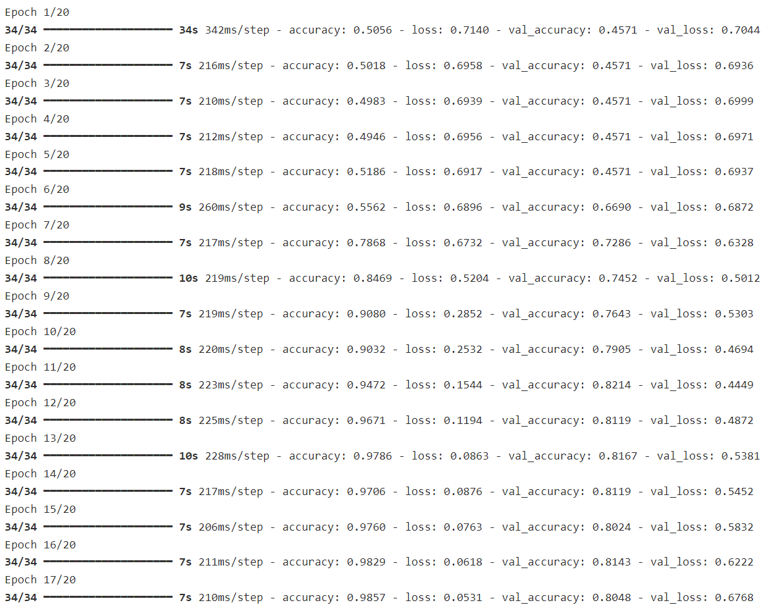

Addressing Overfitting using Stopping Criteria and Discussing Model Fitness
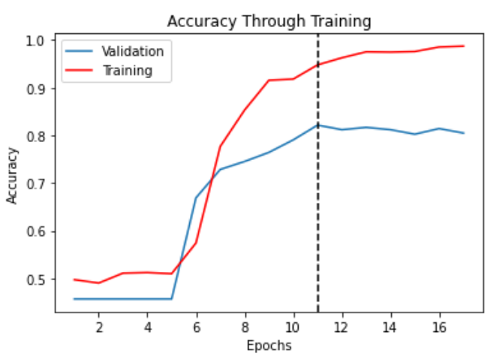
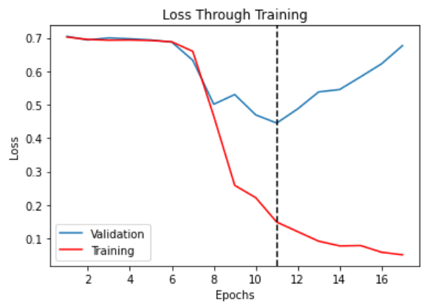
Stopping criteria stopped our model’s training at epoch 17, however that is not the highest performing version of the model in terms of val_accuracy and the model contains heavy overfitting at that point indicated by the loss values. I used the val_accuracy metric and the model checkpoint function to select the highest performing model in terms of validation accuracy. Doing this reduced overfitting slightly, which is all that is necessary. I wanted to build a model that can accurately predict seen sequences and unseen sequences and my model with 95% training accuracy and an average of 80% accuracy between my testing and validation sets prove this model is powerful in identifying sentiment and is especially powerful in predicting sentiment from sentences that are similar to one another.

As you can see the best model is selected right before a massive increase in overfitting as the loss functions become increasingly spread apart, and the validation accuracy maxes out at epoch 11.
I am aware the model does suffer from some overfitting, but I think it’s for the best as validation accuracy is much lower with less of a fit. We can contain the overfitting as a method to recognize sentiments that are similar to one another more accurately. This model should perform well with review sentiments but may not perform well on other types of sequences for example if the author is discussing something scientific or experiment results the model probably will not pick up on the sentiment as there is a very different vocabulary used in those documents.
The final model has a 78.2% prediction accuracy on the test dataset and a 94.7% accuracy on seen data.
Summary and Recommendations
How I Saved the Model
Using the code below we can build a callbacks parameter that exports model weights of the best model from trained epochs up until the stopping monitor based on the validation accuracy of the model. This allowed me to continue training the model on more epochs and extract the best version of the model while using the stopping criteria to stop the model when improvements are not being made.
weights_path = "D:\DataProjects\WGU\Advanced Data Analytics\model_weights_ex.weights.h5"
# Define early_stopping_monitor
early_stopping_monitor = EarlyStopping(patience=6)
checkpoint = ModelCheckpoint(filepath = weights_path,
monitor = 'val_accuracy',
save_best_only = True,
save_weights_only = True)
callbacks = [early_stopping_monitor,checkpoint]

For information about the network architecture go back up to the network architecture section, I have very detailed information about each layer including the type of layer, what the layer does, and how the hyperparameters have been set for each layer. I used rigorous testing to determine the optimal layers and parameters for the network consisting of over 140 trials. I implemented regularization techniques and added the relu activation function right before the prediction layer to tackle the vanishing gradient problem and to attain a model with a strong fit on the training data.
I recommend collecting more data to prevent as much overfitting as possible, but with the dataset we have the model performed pretty well and could be used to do some basic sentiment analysis, but only on sequences that are structured as a review in a sentence or two, the model has not picked up on sequences larger than a sentence or two.

